# Introduction to Windows IoT Core Blockly

Windows 10 IoT Core Blockly[1] lets you program a Raspberry Pi 2 or 3 and a Raspberry Pi Sense HAT using a “block” editor from your browser. This is one of the samples built in to the Windows 10 IoT Core Dashboard[2].

1. Open the web browser. For this lab the default web page is the Blockly Editor.
2. Explore the page. You will see Run and Stop buttons, built in samples such as Heartbeat, building blocks and zoom controls that you can use to centre the block editor, or zoom in and out.

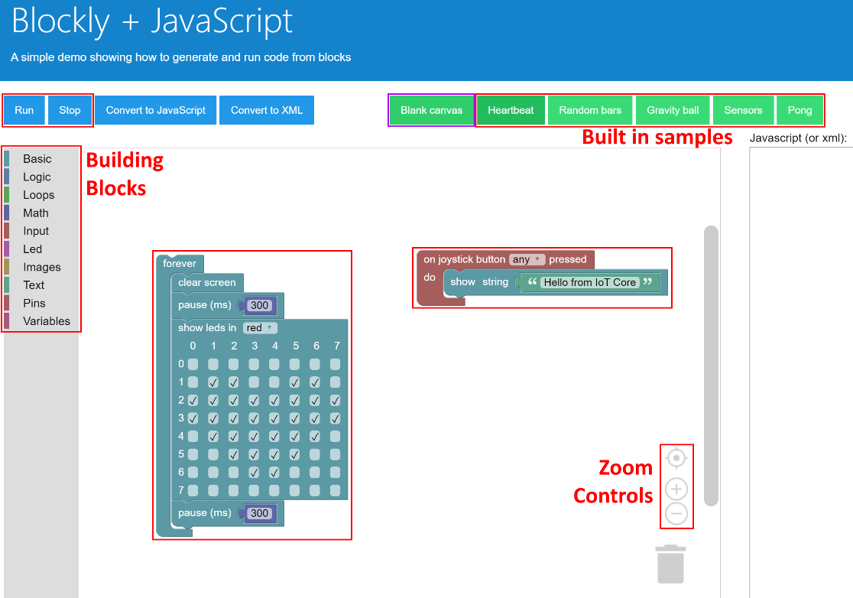

1. Click on the Heartbeat sample, then click Run and you will see a flashing heart on the Raspberry Pi. Have a look at the blocks that make this work. Can you change the colour?
2. 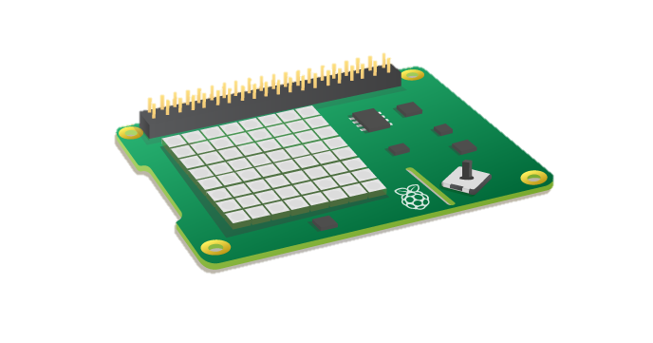Select Gravity ball, then click Run. After some text plays you will see a ball in the middle of the display. Tilt the Raspberry Pi back and forth and observe the ball moving.
3. Try out Pong, using the **joystick** move the paddle left and right to bat the ball.

**Turn Page Over**

# Build Your Own Blockly App

|  |  |
| --- | --- |
| 1. Explore the Building Blocks on the left hand side of the screen. Be sure to check out the Basic, Logic, Input, Maths and Variable Blocks 2. Click on Blank canvas | |
| 1. From Basic blocks, drag the “forever” block to the middle of the screen (Code Zone). |  |
| 1. From the Basic blocks, drag the “clear screen” block and dock inside the “forever” block |  |
| 1. From the Logic blocks, drag the “if do” block and dock below the “clear screen” block. 2. From the Input blocks, dock the “joystick button” to the “if do” block. |  |
| 1. From the Basic blocks, drag the “show leds” block and dock under the “joystick button” block. 2. Tick boxes on the “show leds” block and make a fun pattern. You can also change the colour. 3. From the Basic blocks drag the “pause” block and dock under the “show leds” block. 4. Click Run to send your code to the Raspberry Pi. 5. Press the **joystick** on the Raspberry Pi and you will see your pattern on the display. |  |

1. Windows IoT Core Blockly Parts List http://aka.ms/blocklykit
2. Windows 10 IoT Core Dashboard is available from http://dev.windows.com/iot